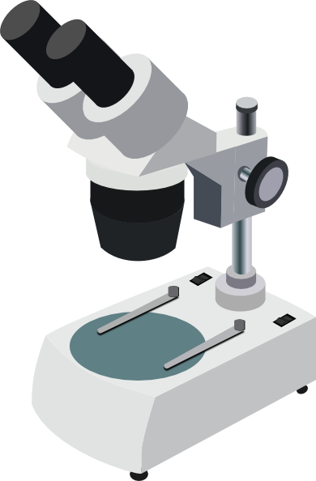

**Science 10**

**Unit C: Biology**

**Chapter 1: The Microscope**

**Name:**

|  |  |  |  |
| --- | --- | --- | --- |
| **Day** | **Key Concepts** | **Pages** | **Homework** |
| 1 | * Microscopes | * #2-5 | * Page 4 |
| 2 | * Microscope Calculations | * #6-9 | * Pages 7, 8, and 9 |
| 3 | * Microscope Lab e |  | * Submit Lab |
| 4 | * Cell Theory * Hidden Kingdom Video | * #10-12 | * Pages 16 and 17 |
| 5 | * Formative Quiz * Graphic Organizer |  | * Graphic Organizers |
| 6 | * **Chapter 1 Quiz** | * 2-12 | * Review Package |

**Cells and Technology**

**The Microscope**

* Egyptians - first created glass 3000 yrs ago
* 1200’s - development of lenses
  + optics - explaining movement of light
* About 1590, two Dutch spectacle makers, Zaccharias [Janssen](http://micro.magnet.fsu.edu/optics/timeline/people/janssen.html) and his father Hans, discovered that nearby objects appeared greatly enlarged. That was the forerunner of the compound microscope.
* In 1609, [Galileo](http://inventors.about.com/library/inventors/blgalileo1.htm), father of modern physics and astronomy, heard of these early experiments, worked out the principles of lenses, and made a much better instrument with a focusing device.
* The father of microscopy, [Anton van Leeuwenhoek](http://www.wikipedia.org/wiki/Anton_van_Leeuwenhoek) of Holland (1632-1723), started as an apprentice in a dry goods store where magnifying glasses were used to count the threads in cloth. He taught himself new methods for grinding and polishing tiny lenses of great curvature which gave magnifications up to 270 diameters, the finest known at that time.
* These lenses led to the building of the first practical microscopes, and the biological discoveries for which Van Leeuwenhoek is famous. He was the first to see and describe bacteria (1674), yeast plants, life in a drop of water, and the circulation of blood corpuscles in capillaries.
* Having discovered the world of bacteria, Leeuwenhoek declared that each had its full complement of bodily organs needed for life.  He opened the doors to microbiology, embryology, histology, entomology, botany and crystallography.
* **Robert Hooke** built one of the first compound light microscopes. He re-confirmed Anton van Leeuwenhoek's discoveries of the existence of tiny living organisms found under the microscope in a drop of water.
* Illustrations drawn by Hooke himself revealed for the first time the eye of fly, the shape of bee's sting organ, the anatomy of a flea and louse and much more.  When he discovered the structure of cork, he coined the term “cells“. The new scientific field of “cytology” – the study of cells, was born.
* Robert Hooke invented the universal joint, the iris diaphragm, and an early prototype of the respirator; invented the anchor escapement and the balance spring, which made more accurate clocks possible, invented or improved meteorological instruments such as the [barometer](http://inventors.about.com/library/inventors/blbarometer.htm), [anemometer](http://inventors.about.com/library/inventors/blweather.htm), and [hygrometer](http://inventors.about.com/library/inventors/blhygrometer.htm); and so on.

**Microscopes**

* Microscopes magnify objects.
* The main benefit 🡪 resolution or the ability to see detail
* 3 main types of microscopes:
  + 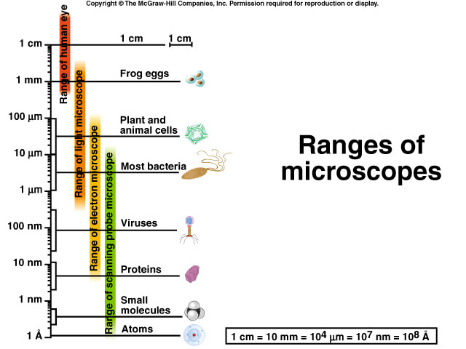____________________________________
  + ____________________________________
  + ____________________________________

**Light Transmission (or Compound) Microscope**

* Greatest magnification: ____________________
* The image is produced by light passing through the specimen
* The image is magnified and focused when the light is bent as it passes through the objective and ocular lenses
* The image is focuses on the back of the eye, the retina
* 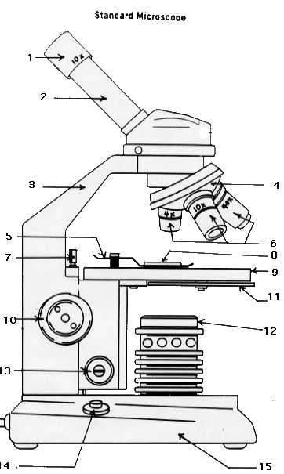The qualities of the image produced are color and three dimensional

Advantages of the light microscope include:

* + _________________________
  + _________________________

Disadvantages include:

* + _________________________
  + __________________________

_____________________________

|  |  |  |
| --- | --- | --- |
| **Part #** | **Part Name** | **Purpose of Part** |
| 1 | Ocular lens | Look through this to see an object under the microscope. Usually 10x magnification. |
| 2 | Body tube | Connects the ocular to the microscope. |
| 3 | arm | Connects the base and the barrel |
| 4 | Revolving nose peice | Turns to change the objective lenses to use. |
| 5 | Stage clips | Holds the slide in place. |
| 6 | Objective lenses | Used to view objects at three different magnifications. |
| 7 | Slide manipulators | Moves the stage side-to-side, or forward and back to get the object into the field of view. |
| 8 | slide | Piece of glass onto which the object to be viewed is placed. |
| 9 | Stage | Holds up the slide for viewing. |
| 10 | Coarse focus knob | Raises and lowers the stage for focusing under low power. |
| 11 | Condenser / diaphram | Adjusts the amount of light entering the field of view. |
| 12 | Light Source | Source of light. |
| 13 | Fine focus knob | Slightly moves the stage to sharpen the image. |
| 14 | Power Switch | Turns the illumination on or off. |
| 15 | Stage | Supports the microscope. |

**Using the diagram on the previous page fill in the part name in accordance with its purpose:**

**Transmission Electron Microscope**

* Magnification: _____________________________________
* The image is produced electrons passing through the specimen
  + shorter wavelength than visible light
  + less scatter - sharper image
* Focusing of the electrons is accomplished by electromagnets
* The image of the specimen is viewed on a TV screen
* Qualities of the image are: two dimensional, high resolution, black and white

Advantages:

* + _________________________________
  + _________________________________
  + _________________________________

Disadvantages:

* + ___________________________________________________
  + ___________________________________________________
  + ___________________________________________________
  + ___________________________________________________

**Scanning Electron Microscope**

* Greatest magnification: ___________________
* Scans the surface of the specimen
* The image is produced by the electrons being reflected off the surface reflected onto a screen
* Often coat specimen with gold for a sharper image
* Focusing of the electrons is by electromagnets
* The image is produced on the monitor
* The qualities of the image are: 3 D black and white picture of the surface of the specimen.

Advantages:

* + __________________________________
  + __________________________________

Disadvantages:

* + __________________________________

**Microscope Calculations**

**Units of Measurement**

Whenever you use a microscope you will likely have to calculate **magnification, field of view diameter** and **scale.** Objects viewed under a microscope are very small so we usually express their dimensions in micrometres. There are **1** 000 μ**m in 1 mm** (1 000 000 μm in a mL). Look at a metric ruler, identify the lines that are 1 mm apart and imagine how close the lines would be if there were 1 000 of them between the two marks. To convert from mm to um you multiply the value in mm by 1 000.

|  |  |  |  |
| --- | --- | --- | --- |
| 0.018 mm | =_____18_____μm | 250 μm | =____0.250______ mm |
| 240 000 μm | =______240____ mm | 32 000 μm | =___32_______ mm |
| 364 mm | =_____364000_____ μm | 0.567 mm | =____567______ μm |
| 4.5 mm | =____4500______ μm | 0.879 mm | =____879______ μm |
| 79 mm | =____79000______ μm | 27.5 mm | =____27500______ μ m |

**Magnification**

To determine the magnification of a light microscope you multiply the magnification of the objective you are using by the magnification of the eyepiece (ocular).

**Total Magnification = Eyepiece Power X Objective Power.**

**10 X 4 = 40X**

1. If your microscope had an 8X eyepiece and a 20X objective lens, what would the magnification be?

20 x 8 = 160x

1. If your microscope had a 15X ocular and the low, medium and high power objectives were labelled 10X, 20X and 40X, calculate the three possible magnifications for this microscope?

Low _______150x________ Medium ________300x_________ High ______600x_______

**Field of View Diameter**

The field of view diameter is a measure of the width of the circular area seen through the ocular. You can determine the diameter of the field of view by focusing on a metric ruler, counting the number of mm and then, if necessary, converting to um. By comparing the size of the image to the known diameter of the field of view you can estimate the size of the object you are viewing.

Under low power you are able to see 4.25 divisions on a metric ruler. If each division is 1.0 mm, what is the diameter of the field of view in both mm and μm?

4.25mm = 4250μm

Under medium power you are able to see 1.75 divisions on a metric ruler. If each division is 1.0 mm, what is the diameter of the field of view in both mm and μm?

1.75mm = 1750μm

**Use the following diagram to answer the next question**



3. The diameter of the low power field of view is 2 000 μm. If four lily cells fit across the field of view, how long is each cell in mm? 500μm

4. If the field of view under 400X is 500 μm, how many 200 μm long cells could be seen ends to end across the field of view (to the nearest 0.10 of a cell)? 2.5 cells

###### Relating Magnification to Diameter of Field of View

An inverse relationship exists between magnification and field of view. **As magnification** **increases, field diameter decreases.** If you know the field of view diameter under one magnification, you can determine the field of view diameter under any other magnification by using the following formula:

**magnification 1 X field diameter 1 = magnification 2 X field diameter 2**

**M1FD1 = M2FD2**

***Note that the units must be the same for both (1 and 2) field of view.***

**For example**: If the field of view of a microscope under 100X is 3.60 mm, what is the diameter of the field if we increased the magnification to 150X?

**100 X 3.60 mm = 150 X field diameter 2**

**100 X 3.60 mm = field diameter 2**

**150**

**2.4 mm = field diameter 2**

1. A microscope has a medium power (100X) field of view of 1.75 mm. What is this diameter in μm? What is the diameter of the high power (400X) field of view in **both** mm and μm?

* 1. 1750μm
  2. 0.4375 mm or 437.5μm

2. A student counts 6 cells across the diameter of the field of view of a microscope and 8 rows of cells down. The magnification is 50X and the diameter of the field is 2 400 μm.

a) What is the length and width of each cell in μm?

400 μm wide and 300μm long

b) If the magnification were increased to 200X, what would be the diameter of the field of view?

600μm

c) Under 200X magnification, how many cells could be seen across and down the field of view?

1.5 cells and 2.0 cells**Science 10 Microscope Calculations – Extra Practice**

1. Convert the following measurements:

0.039 mm = __________ μm 375 μm = __________ mm

123 μm = __________ mm 0.789 mm = __________ μm

19.5 mm = __________ μm 32 000 μm = __________ mm

1. If your microscope had a 5X eyepiece and a 20X objective lens, what would the magnification be?
2. If your microscope had a 10X ocular and the low, medium and high power objectives were labelled 4X, 10X and 40X, calculate the three possible magnifications for this microscope?

Low __________________ Medium ____________________ High ________________

1. If your microscope had a magnification of 300X and the magnification of the ocular lens was 15x, what would the magnification of the objective lens be?
2. Under low power you are able to see 4.75 divisions on a metric ruler. If each division is 1.0 mm, what is the diameter of the field of view in both mm and μm?
3. The diameter of the low power field of view is 3 000 μm.

a) If five lily cells fit across the field of view, how long is each cell in μm and in mm?

* 1. If six lily cells fit up and down the field of view, how wide is each cell in μm and in mm?

1. If the field of view under 400X is 500 μm, how many 100 μm long cells could be seen end to end across the field of view ( to the nearest 0.10 of a cell)?
2. A microscope has a medium power (100X) field of view of 3.25 mm. What is this diameter in μm? What is the diameter of the high power (400X) field of view in **both** mm and μm?
3. A student counts 8 cells across the diameter of the field of view of a microscope and 9 rows of cells down. The magnification is 40X and the diameter of the field is 4 800 μm.
4. What is the length and width of each cell in μm?
5. If the magnification were increased to 400X, what would be the diameter of the field of view?
6. Under 400X magnification, how many cells could be seen across and down the field of view?

**Key:** **1**a) 39 b) 0.123 c) 19500 d) 0.375 e) 789 f) 32 **2**. 100x **3.** 40x, 100x, 400x **4.** 20x **5.** 4.75 mm, 4750 μm **6.** a)600 μm/cell, b) 500 μm/cell **7.** 5.0 cells **8.** 0.8125mm, 812.5 μm **9.** a) 533.3 μm, 600 μm b) 480 μm c) 0.90 cells, 0.80 cells

**The Cell**

What is a Cell?

* + ____________________________________________________________
  + ____________________________________________________________

All Living things share five characteristics

1. _____________________________
2. _____________________________
3. _____________________________
4. _____________________________
5. _____________________________

**Abiogenisis (Spontaneous Generation):**

How did Louis Pasteur disprove spontaneous generation?

How did Francisco Redi disprove spontaneous generation?

Cell Theory

* Development of Cell Theory
  + 1590 – compound microscope invented
  + 1665 – **Robert Hooke** noticed structures while viewing slices of cork – cells
  + 1700 – **Anton van Leeuwenhoek** observes living cells with a microscope
  + 1700 + - more structures identified as technology gets better
  + 1838 – Schwann and Schleiden proposed that plant and animal tissue are made of cells

**The Cell Theory**

1. __________________________________________________________________
2. __________________________________________________________________
3. __________________________________________________________________