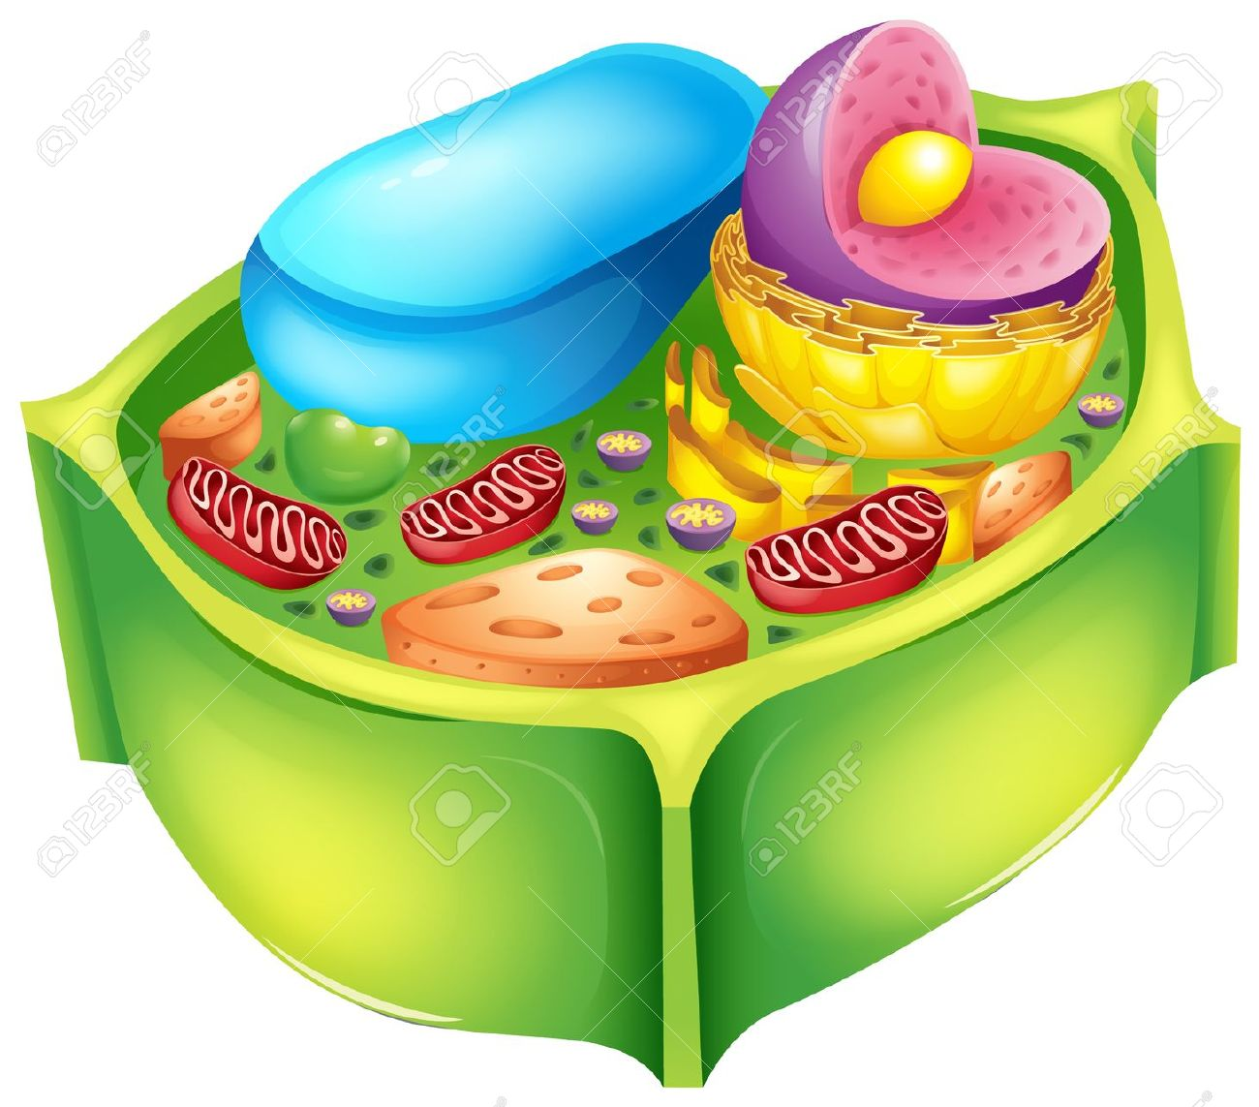

Science 10

Unit C Biology

Chapter 2: The Cell

Name:

Day | Key Concepts | Pages | Homework
1 | - Cell Organelles | - #2-4
2 | - Cell Organelles | - #5-6 | - Pages 6 and 7
3 | - Formative Quiz  - Graphic Organizer 2 |  | - Graphic Organizer 2
4 | - Chapter 2 Quiz | - 2-6

The Cell

Objectives: After studying this Topic you should be able to:
- Identify and briefly describe the structure and function of the nucleus, nucleoid, endoplasmic reticulum, Golgi apparatus, lysosome, vacuole, mitochondrion, chloroplast, ribosome, cytoskeleton and cell wall, where present, in bacteria, plant and animal cells

Prokaryotic Cells
General Characteristics

- _______________________________________________________________
- _______________________________________________________________
- _______________________________________________________________
- _______________________________________________________________
- _______________________________________________________________
Eukaryotic Cells
Two types

- ______________
- ______________

Plant vs. Animals
Plant cells and animal cells differ in a few ways.

- __________________________________________
- __________________________________________
- __________________________________________
- __________________________________________

Organelles Structure & Function
- Nucleus
  - ____________________________________
  - ____________________________________
  - ____________________________________
Nucleolus:
- Nucleolus
  - ____________________________________
  - ____________________________________
  - ____________________________________

- Chromosomes
- DNA is organized with proteins into multiple, linear chromosomes
- Chromatin is the term used to represent the mass of stringy, entangled chromosomes observed during interphase (between cell divisions)
Chromatin:

- Nucleoplasm
- ______________________________________
- ______________________________________

- Cytoplasm
- Gel like substance inside ______________
- Dissolves nutrients throughout the cell
- _________________________________
- keeps them from banging into each other.
Mitochondrion:
- Mitochondrion
- organelle within all cells
- looks like a long worm inside a sandwich bag
- _____________________________________
- _____________________________________
- _____________________________________

- Vacuole
  - a hollow organelle that stores water, nutrients and waste
- _________________________________
- _________________________________
RIBS = protein
RIBS = RIBoSomes

- Ribosomes
- very very small snowman shaped organelles
- ____________________________________
- Endoplasmic Reticulum (ER)
ER:
- long system of tubes and canals throughout cell
- _______________________________________
    - like a subway system in a city
- Two types of Endoplasmic Reticulum
    - _________________ – ribosomes attached to the ER
    - _________________ - no ribosomes attached

    - Golgi Complex
Golgi:
  - looks like a stack of pancakes
  - packages materials (proteins…) for export
  - intercellular transport
  - like a shipping department for an industrial factory

      - Lysosome
- Spherical bodies
- Contains enzymes
- Intracellular digestion
Centrioles:

      - Centrioles
- Rod-like structures containing microtubules
- Cell division in animals

Chloroplast:
- Chloroplast
  - __________________________________
  - captures light energy
  - __________________________________

- Cell Wall
  - __________________________________
  - __________________________________
  - Made up of cellulose

    - Cell Membrane
- Retains cell contents
- _____________________________________
- _____________________________________

Organelle | City Part
A Cell is like a City…..

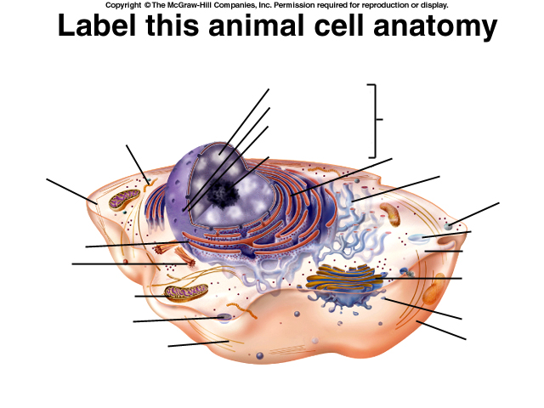

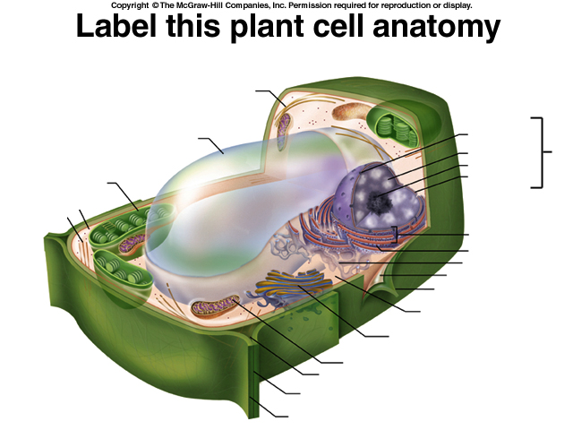

What are all the differences between plant and animal cells?

