Science 10
Unit A – Chemistry
Unit Exam Study Guide

Section 1

Section A 1.1
- Lab safety
- WHMIS and MSDS

Section A 1.2
- Chemical and physical properties
- Chemical and physical changes
- Classifying matter
- 5 Signs of chemical reactions

Section A 1.3 – The History of Chemistry
- Atomic models and history (Bohr, Rutherford, etc.)
- Subatomic particles (mass and charge)

Section 2

Section A 2.1 – The Periodic Table
- Patterns of the table
  - Families/ Groups (and names )
  - Periods
  - Atomic number
- Atomic theory and electron energy levels
  - The rule of 8
- Isotopes and symbols
- Ionization (rule of 8)
- Naming ions (cation vs. anion)

Section A 2.2 – Ionic vs. Molecular compounds
- Classification and naming
- Naming and formulas for ionic compounds
  - Simple ionic
  - Multivalent ionic
  - Complex ionic
- Naming and formulas for molecular compounds

**MEMORIZE THE PREFIXES**
#Atoms | 1 | 2 | 3 | 4 | 5 | 6 | 7 | 8 | 9 | 10
Prefix | mono | di | tri | tetra | penta | hexa | hepta | octa | nona | deca
**MEMORIXE TABLE A 2.12**

Name | Chemical Formula
water | H₂O
hydrogen peroxide | H₂O₂
ammonia | NH₃
sucrose | C₁₂H₂₂O₁₁
methane | CH₄
propane | C₃H₈
methanol | CH₃OH
ethanol | C₂H₅OH
hydrogen sulphide | H₂S

- Naming and formulas for acids
  - How do you recognize an acid?

Section A 2.3 – Properties of Ionic & Molecular compound and Acids & Bases
- Conductivity
- Solubility solubility table
- Phase at room temperature
- Colour of solutions

Acid and Bases properties
- Bases are ionic hydroxides
- Acids are aqueous solutions with H as a cation
- Indicators, pH scale, buffers,
- Acid + Base reaction = neutralization

Section 3

Section A 3.1 – Chemical Change
- Example of chemical change
  - Gas formation, solid formation (precipitate), energy (exothermic/endothermic)
  - Photosynthesis and Cellular respiration
  - Conservation of mass

Section A 3.2 – Word equations and Chemical equations
- Balancing
- 5 types of reactions – classification
  - formation, decomposition, hydrocarbon combustion, single replacement and double replacement.
- Predict reactions and products

A1.1 - WHMIS SYMBOLS

Write the name of the safety symbol beside each of the symbols on the left.

WHMIS Symbols
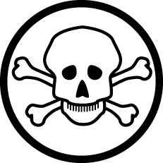
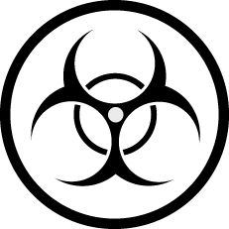
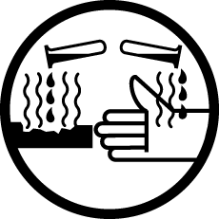

BONUS: What does “WHMIS” stand for?

Chemical vs. Physical Properties
List as many chemical and physical properties as you can.
CHEMICAL PROPERTIES | PHYSICAL PROPERTIES

Chemical change vs. Physical change
Classify the following as chemical (C) or physical (P) changes. (1 mark each)

  - Car rusting _________

  - Digesting food _________

  - Sweat evaporating _________

  - Burning paper _________

  - Making ice _________

  - Bubbling soup in a pot _________

Fill in the missing terms in the following chart about the organization of matter:

MIXTURES

Homogeneous Compounds
Mixtures
(Solutions) Ex) Carbon, Ex)
Oxygen, Iron

Periodic Table Review
- For the periodic table and it’s parts & atomic structure, complete the following:

  - The vertical columns are called _________________ or __________________, and horizontal rows are known as ___________________.
  - ____________ are found to the left of the staircase, while _________________ are found to the right of the staircase. Elements that are located very close to the staircase are called _______________________.
  - Group #1 is known as the ____________________________________
  - Group #2 is known as the ____________________________________
  - Group #17 is known as the ____________________________________
  - Group #18 is known as the ____________________________________
  - In general, the elements in the middle of the table are called _________________________

- In the atom, the nucleus consists of ___________________ and ____________________. Orbiting around the outside are ___________________.

- How do you determine the atomic number of an atom?

- What is an isotope? How do you determine the mass number?

- What is an ion? When do they form?

- Another name for a positive ion is _______________. Another name for a negative ion is _______________.

- The name for the outer electrons is _______________ electrons.
- ______________ compounds transfer electrons, whereas _________________ compounds have covalent bonds.
Atoms and Ions Practice
Name | Symbol | Mass Number | Atomic Number | Protons | Neutrons | Electrons | Electric  Charge
fluorine atom | F | 19 | 9 | 9 | 10 | 9 | 0
nitride ion | N³⁻ | 15 | 7 | 7 | 8 | 10 | 3−
boron atom |  | 11
carbon atom |  | 14
aluminium ion |  |  |  |  | 14 |  | 3+
gold ion |  |  |  |  | 116 |  | 1+
 |  | 40 |  | 19 |  |  | 0
 |  | 79 | 35 |  |  | 35
 |  |  |  |  | 19 | 18 | 1−
 |  |  |  | 16 | 16 |  | 2−
 | Ag | 110
cesium ion |  |  |  |  | 77 |  | 1+
 | I⁻ | 125

Complete the following table. Each blank is worth 1 mark.
 | Chemical Formula | Chemical Name
1 | H₂O
2 |  | tribromine nonasulphide
3 | Zn₃N₂
4 |  | gold ( III ) nitrate
5 |  | sulfur
6 | Na₃PO₄
7 |  | sucrose
8 | SrF₂
9 |  | calcium sulphite
10 |  | lead (IV) carbonate
11 | NH₃
12 | Al(ClO₃)₃
13 | Cu₂O
14 |  | ozone
15 | Ba(MnO₄)₂
16 | H₃P _{(aq)}
17 |  | potassium bicarbonate
18 |  | hydrogen
19 | (NH₄)₂SO₄
20 |  | nitrogen monoxide

Complete the following table. Each blank is worth 1 mark.
 | (i)onic,  (m)olecular,  (a)cid | Chemical Formula | Chemical Name
1 |  | CH₄
2 |  |  | carbon tetrachloride
3 |  | Al₂O₃
4 |  |  | iron ( III ) sulphate
5 |  |  | acetic acid
6 |  | CaCO₃
7 |  |  | ammonia
8 |  | UO₃
9 |  |  | strontium nitrite
10 |  |  | copper (II) phosphate
11 |  | H₂SO_{4 ( aq )}
12 |  | FrI
13 |  | Br₃S₈
14 |  |  | aluminum hydrogen phosphate
15 |  | Ba₃N₂
16 |  | H₃N _{(aq)}
17 |  |  | potassium permanganate
18 |  |  | chlorine
19 |  | Sn(HCO₃)₄
20 |  |  | sulphurous acid

SOLUBILITY OF IONIC SUBSTANCES

FILL IN THE FOLLOWING TABLE, WRITE THE FORMULA OR NAME OF EACH CHEMICAL. INDICATE WHETHER THE IONIC COMPOUND LISTED IS SOLUBLE (aq) or INSOLUBLE (s) IN SOLUTION.
YOU MAY PUT EITHER “aq” OR “s”.

# | FORMULA | NAME | aq or s
1 | AgCl
2 | CaS
3 | Cu(NO₃)₂
4 | AgCH₃COO
5 | NaCH₃COO
6 | CuO
7 | CoS
8 | Al(OH)₃
9 | Ca₃(PO₄)₂
10 | TlOH
11 |  | thallium(III)hydroxide
12 |  | francium carbonate
13 |  | barium phosphate
14 |  | mercury (I) bromide
15 |  | silver chlorate
16 |  | ammonium sulfide
17 |  | lead (II) sulfate
18 |  | potassium hydroxide
19 |  | copper (II) iodide
20 |  | zinc perchlorate

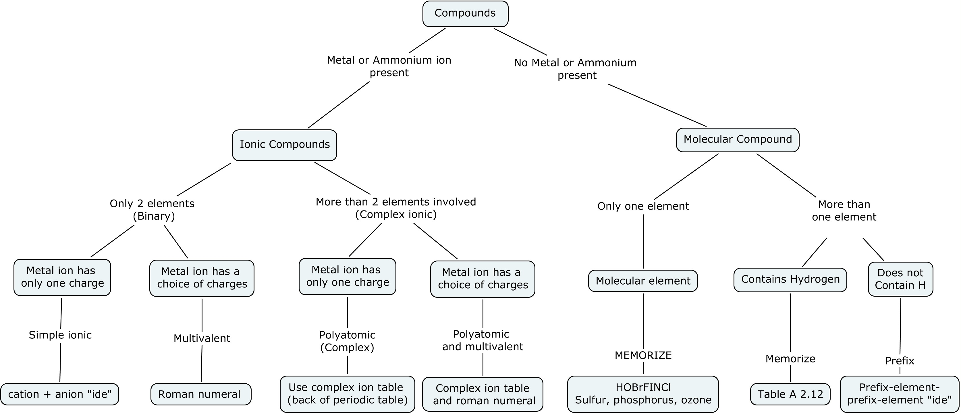

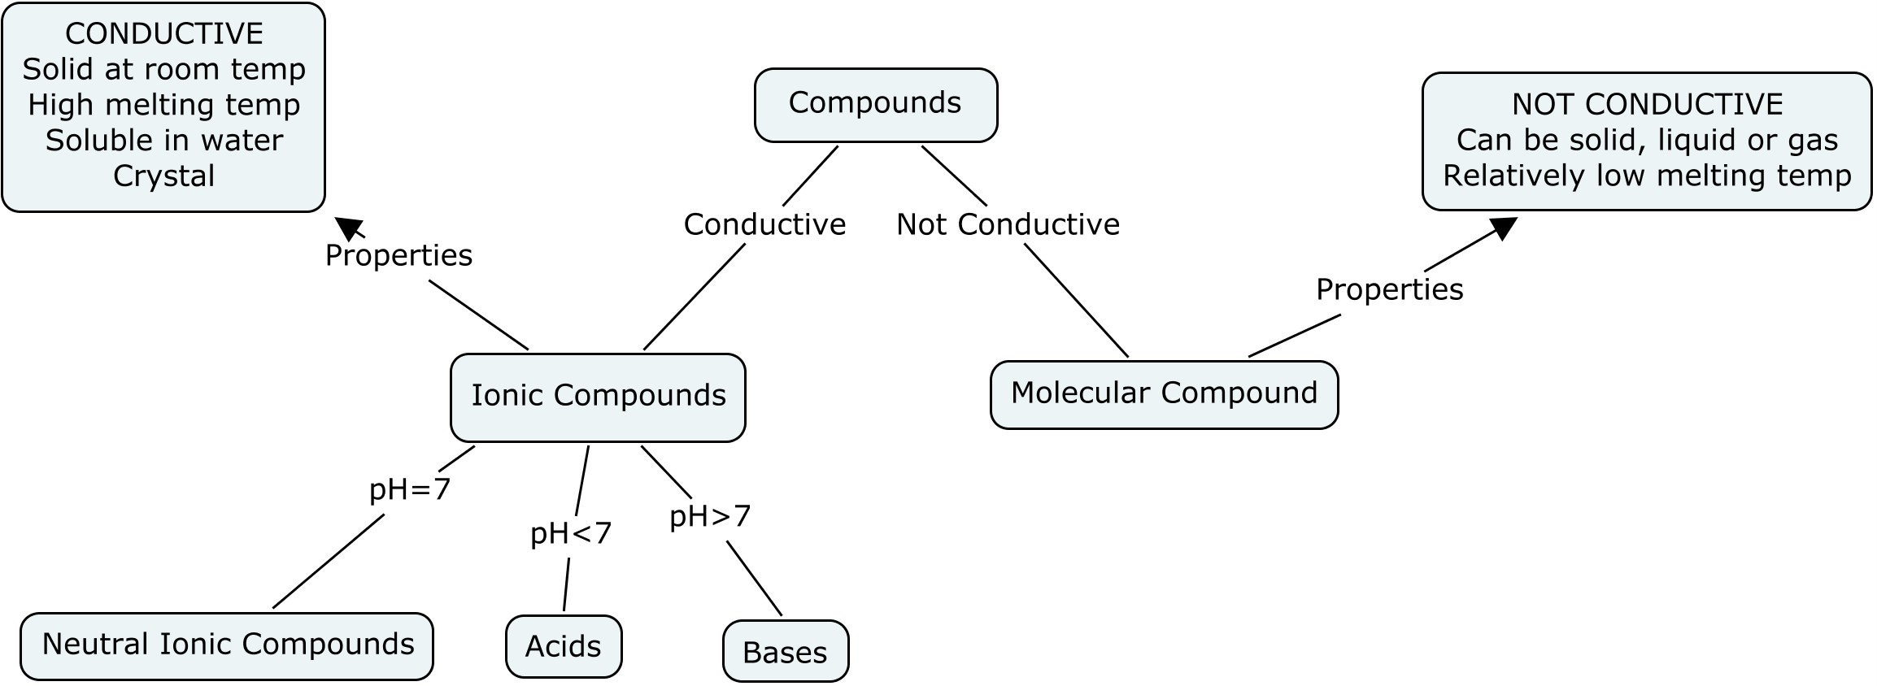

For the following reactions:

1) Change the word equations to proper formulas.
2) Balance the overall equations.
3) Indicate on the line in the right hand margin whether the reaction is a (F)ormation, (D)ecomposition,
(SR)Single Replacement, (DR)Double Replacement, or (HC)Hydrocarbon Combustion reaction.
4) For the last two reactions, you must predict the products of the reaction (formulas only) before balancing.
BONUS: Indicate the STATES of each substance (g), (l), (s), or (aq)

- strontium + nitrogen strontium nitride ______

- sucrose + oxygen carbon dioxide + water ______

- chromium (III) oxide chromium + oxygen ______

- magnesium + silver nitrate solution ___________ + ___________ ______

- lead (II) nitrate + sodium sulfate solution _______ + _______ ______

