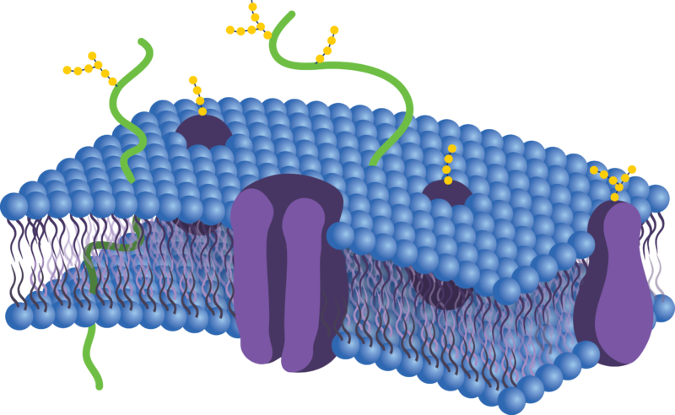**Science 10**

**Unit C Biology**

**Chapter 3: Cell Membrane, Transport and Size**

**Name:**

|  |  |  |  |
| --- | --- | --- | --- |
| **Day** | **Key Concepts** | **Pages** | **Homework** |
| 1 | * Cell Membranes | * #2-6 | * Page 6 |
| 2 | * Active and Passive Transport | * #7-14 | * Pages 14 |
| 3 | * Membrane Technologies * Surface Area to Volume Ratios | * #15 * #16-18 | * Page 15 and 18 |
| 4 | * Review * Graphic Organizer |  | * Graphic Organizer |
| 5 | * **Chapter 3 Quiz** | * 2-18 |  |

**Cell Membrane and Transport**

Objectives**: After studying this Topic you should be able to:**

* Describe the structure of the cell membrane.
* Distinguish between the terms passive and active transport.
* Describe the following forms of cell transport: diffusion, osmosis, active transport, exocytosis and endocytosis
* Describe the effects of hypertonic, hypotonic and isotonic solutions on plant and animal cell

## **Structure of the Cell Membrane**

The membrane is a very important component of all living cells. The cell membrane controls the movement of nutrient and waste substances into and out of the cell. It is composed of molecules called **phospholipids** and **proteins**

1. Cell membrane is composed of ________________________ & _______________ arranged in two layers called a ________________________________________
2. The membrane is made up of phosphate molecules that are______________________ (water loving) heads and fat [lipid] molecules that are _______________________ (water hating) tails.
3. The membrane is _____________________ allowing things drift past each other.

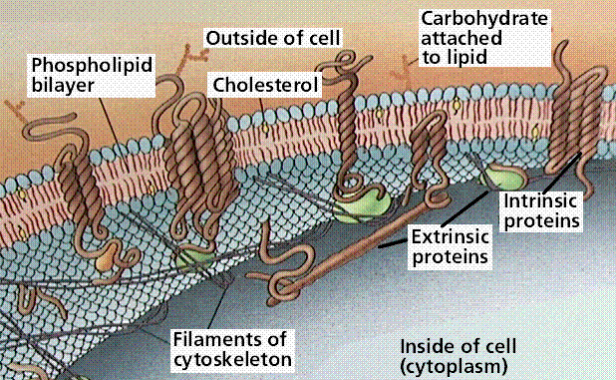

Functions of the Cell Membrane:

The cell membrane acts as a barrier. However, cells must take in food and eliminate wastes in order to maintain a constant internal environment.

Since only certain substances are allowed to cross the membrane, movement across cell membrane is therefore called _____________________________

***selective transport***.

Membranes can be classified in the following ways:

|  |  |
| --- | --- |
| ***Impermeable***: | does not let anything pass through the membrane;  Hydrophillic or “water loving |
| ***Permeable***: | allows all materials to pass through the membrane;  Hydrophobic or “water – hating” |
| ***Semi-permeable***: | allows some particles to pass through the membrane while excluding other particles |

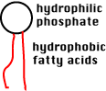

Phospholipid Molecule Structure:

|  |  |
| --- | --- |
| Phosphate Head | Hydrophillic or “water loving |
| Lipid Tail | Hydrophobic or “water – hating” |

* This chemical makeup accounts for the fluidity of the membrane and indicates how these molecules will be arranged in the membrane.
* Phospholipids arrange themselves into two layers referred to as a ______________________**phospholipid bilayer**.
  + **Lipid tail points inward, away from water**
  + **Phosphate heads point outward, towards water**
* Embedded in the bilayer are various types of ___________________________proteins

**Outside the Cell**

**Inside the cell**

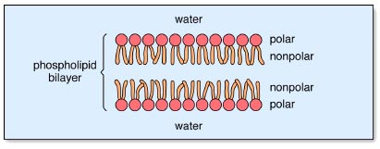

* The head of the molecule contains a phosphate group which is __________________________________(water loving)
* Lipids are fat molecules with long tails that are _______________________________ (water hating)

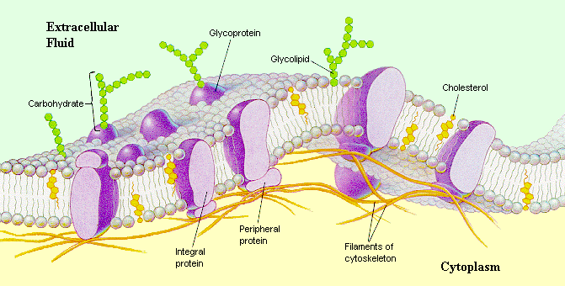

**Glycolipid**

**Glycoprotein**

**Membrane Proteins**

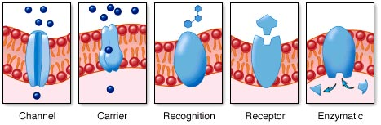

**Read the following information and summarize two functions of membrane proteins in the chart below.**

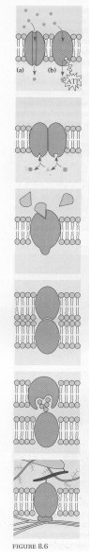The arrangement of the phospholipid bilayer is very important because it gives the cell membrane the ability to transport both fat-soluble and water soluble molecules into and out of the cell. The embedded proteins serve many functions.

**Membrane Proteins**

1. **Transport Proteins:**

**1**

* Channel Protein: These proteins form channels or passageways through the cell membranes. They allow small water soluble particles to pass through the hydrophobic (water hating) phosphlipid layer.
* Membrane Pumps: Use energy to move particle across the cell membrane.

1. **Enzymes:** Some proteins embedded in the membrane help to speed up chemical reactions need by the cells to live.

**2**

1. **Hormone Receptor Sites:** Hormones are chemical messengers carried by the blood in the body. They allow cells to communicate with each other to control body functions such as growth or sexual reproduction

**3**

1. **Attachment to other cells:** Some membrane proteins allow cells to attach to each other to form tissues.

**4**

1. **Cell to Cell Recognition:** Glycoproteins are protein molecules that carry a special sugar molecule. The sugar molecules provide the cell with a special signature that is unique to that cell. Your immune system identifies foreign invaders by recognizing their unique structure on the cell membrane. This helps to explain why transplanted organs are often rejected by the person receiving the organ, the recipient. The white blood cells do not recognize the glycoproteins of the donated organ and begin to destroy the cells.

**5**

1. **Attachment to the cytoskeleton:** Some proteins help the cell membrane stay attached to the cytoplasm.

**6**

**Describe an analogy of two functions of membrane proteins:**

* **Function One:**
* **Function Two:**

**ASSIGNMENT**: **Answer the following questions and label the diagrams.**

1. What is the general purpose of the cell membrane?
2. What are the two main molecules that make up the cell membrane?
3. Label the side view of the membrane

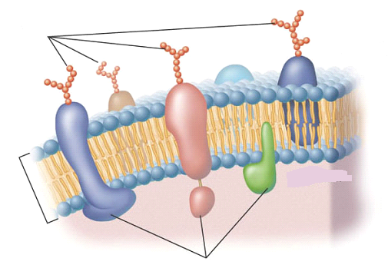

1. Label the three-dimensional view of membrane

**1**

**2**

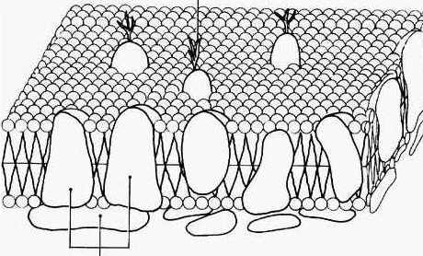

1. Explain why blocking all transport across a cell’s membrane would shorten the cell’s lifespan.

**Transport across Cell Membranes**

* Since only certain substances are able to cross, movement across the cell membrane is termed **selective transport.**
* Substances needed by the cell move into and out of the cell using___________________________

passive or active transp

|  |  |
| --- | --- |
| Passive Transport |  |
| Active Transport |  |

Passive Transport

* Movement across cell membranes without an input of energy is called ***passive transport***, and includes diffusion, osmosis, and facilitated diffusion.
* Two types of Passive Transport are:

The particle model of matter states that all matter is made up of tiny particles. ***Brownian*** ***motion*** refers to the fact that these particles are in constant, random motion. This random motion allows for the net movement of particles towards areas of lower concentration. A state of ***equilibrium*** is reached once these molecules are distributed evenly. If they are not distributed evenly, there is a difference in concentration between two areas which we call the ***concentration gradient***.

Define Diffusion: The random movement of molecules from an area of higher concentration to an area of lower concentration

|  |  |
| --- | --- |
| 0068l |  |

Define Concentration Gradient: The difference in concentration between two areas

* Molecules always move from high concentration to low concentration regardless of the amount of other substances mixed with them
* Molecular collisions cause diffusion and there are 3 factors that affect the rate of diffusion:

1. *______________________________: Concentration gradient*: The greater the difference the faster diffusion
2. *______________________________:Temperature*: The greater the temperature the faster the particles move
3. *Particle size___________* ______________________________: The larger the particle the slower the movement

Diffusion continues until equilibrium is reached:

Define Equilibrium: is a condition in which the concentration of particles is equally distributed

* At this point diffusion stops but molecules move back and forth across the membrane at an equal rate

Facilitated Diffusion:

Uses transport proteins to aid, assist, or facilitate the diffusion of particles across the cell membrane.

***___________________________:*** are membrane proteins that help move materials across the membrane. There are 2 types of transport proteins and they are recognized based on their shape, size, and electrical charge:

* 1. ***_________________________:*** this membrane protein changes shape to allow certain molecules to cross the cell membrane.
  2. ***_________________________:*** this membrane protein forms tunnel-like pores in the cell membrane, allowing electrically charged ions in and out of the cell.

Define Osmosis:

* ______________________________
* Selectively permeable
  + The ability of a cell’s membrane to allow certain substance to pass through more readily than others

Terms Related to Osmosis

|  |  |
| --- | --- |
| Solute: | molecules that are dissolved in a solvent |
| Solvent: | Substance that dissolves solute – in the case of osmosis – water!! |
| Dialysis membrane: | a membrane that allow the movement of molecules based on size |

Solution Types

* The cytoplasm of a cell never contains water alone and neither does a cell’s exterior (i.e. the extracellular fluid). Cells contain other molecules dissolved in the water called solutes
* There are three types of solutions:



If the solute concentration on one side of the cell membrane is **higher** than on the other side, the solution is said to be **hypertonic**. The solution with the **lower solute** concentration is **hypotonic.** Small solutes will diffuse from areas of high concentration to low concentration. The direction in which water (the solvent) will move is affected by the solute concentration. If we compare two sides of a semipermeable membrane, the solute concentration may be different. Water will diffuse from areas where it is more concentrated (low solute concentration or hypotonic) to areas where it is less concentrated (high solute concentration or hypertonic). Ideally, cells are bathed in isotonic solutions-solutions in which the solute concentration outside the cell is equal to that inside the cell. In isotonic solutions the water movement into a cell is balanced by the water movement out of the cell.

Types of Solutions:

1. ***Hypotonic Solutions*:** contain a **low concentration of solute** relative to another solution (e.g. the cell's cytoplasm). When a cell is placed in a hypotonic solution, the water diffuses into the cell, causing the cell to swell and possibly explode.
2. ***Isotonic Solutions*:** contain the **same concentration** of solute as another solution (e.g. the cell's cytoplasm). When a cell is placed in an isotonic solution, the water diffuses into and out of the cell at the same rate (equilibrium). The fluid that surrounds the body cells is isotonic
3. ***Hypertonic Solutions*:** contain a **high concentration of solute** relative to another solution (e.g. the cell's cytoplasm). When a cell is placed in a hypertonic solution, the water diffuses out of the cell, causing the cell to shrivel.

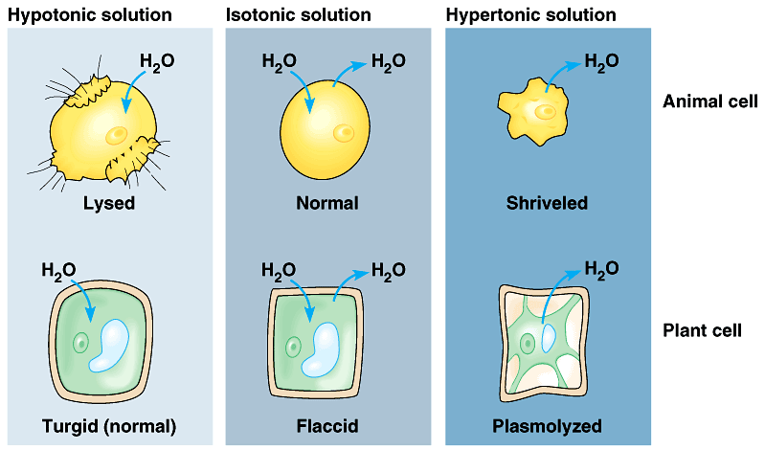

Osmosis in Living Cells:

* Osmosis is what keeps plant cells plump and full of water so that the plants do not look wilted.
* Water pressure inside a plant cell pushes against the rigid cell wall causing **turgor pressure**.
* The walls of plant cells are able to withstand a great deal of turgor pressure.
* This is not the case with animal cells. If an animal cell takes in too much water by osmosis, it will burst (**lysis**).

**Animal Cells**

**Plant cells and tugor pressure**

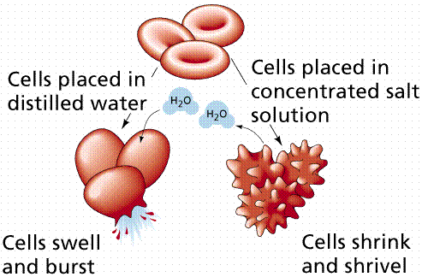

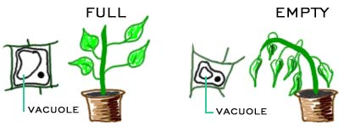

###### What to Do

Below are three diagrams that show three identical cells in three separate beakers of solution. The relative concentration of water and solute molecules is given for the cell in each beaker. Complete the diagrams by drawing the molecules of water and solution required to make the external fluid in each beaker hypertonic, isotonic, or hypotonic, as indicated. Use arrows to show the direction of water flow, with a thicker arrow indicating more molecules moving in one direction.

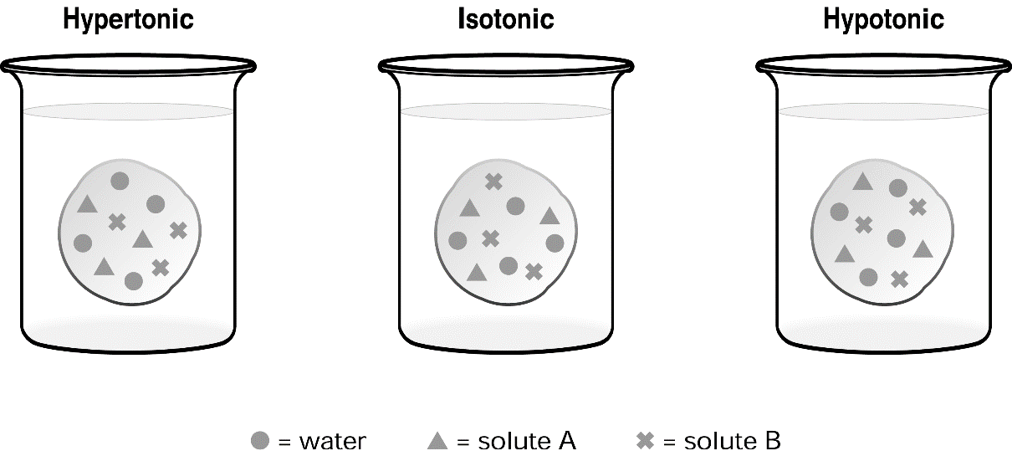

**Answer the following questions:**

1. Distinguish between osmosis and diffusion

Diffusion is net movement down a concentration gradient of molecules of any substance

Osmosis is only diffusion of water across a membrane

1. What makes osmosis and diffusion similar?

In both, the molecules of a substance flow down a concentration gradient. Both are passive and do not require energy.

1. Explain why facilitated diffusion is considered a form of passive transport, even though it uses membrane proteins.

Active Transport

Movement across cell membranes that requires an input of energy is called ***active transport***.

* Always requires the cell membrane. Energy _____________ is used
* Substance are often transported from an area of _____________________________to an area of ___________________________
  + AGAINST their concentration gradients
* Two types: Transport Protein, and Cell Membrane (Endocytosis and Exocytosis)

Active transport mechanisms involving a transport protein are called "pumps".

Example: Sodium pump mechanism

* Sodium ions (Na+) naturally diffuse into cells and
* Potassium ions (K+) naturally diffuse out of cells.
* 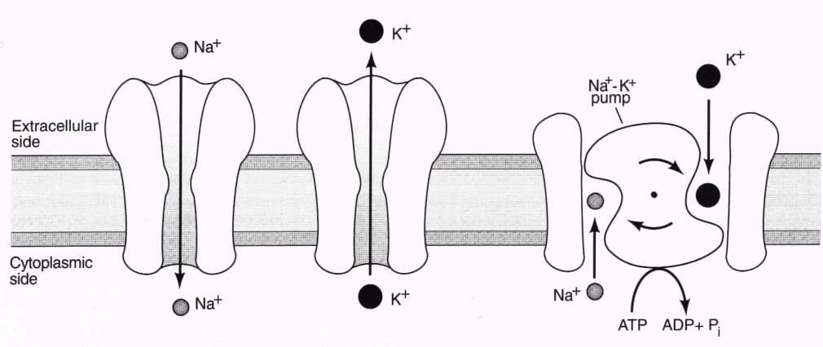Cells want K+ but not Na+, so Na+ must be pumped out and K+ must be pumped in!
* Na+ K+ pump uses carriers x and y.

**Cell Membrane - Endocytosis and Exocytosis**

***Endocytosis***: Cells engulf large particles by extending their cytoplasm around the particle

* This process is used by cells to take in substances, in which the membrane folds in, encloses the item in a sphere, then pinches off a ***vesicle***.
* The ingested particle is trapped within a pouch or vacuole, inside the cytoplasm
* Enzymes from the lysosomes are often used to digest the large particle absorbed
  + The sphere may also form a ***vacuole***, which acts as a storage site for the ingested material. Membrane proteins called ***receptors*** protrude from the membrane surface and assist in endocytosis. These receptors detect, identify, and then bind to various compounds or cells, which in turn triggers endocytosis. This process is called ***receptor-mediated endocytosis***.

Two Types of Endocytosis (depending on particle size)

|  |  |
| --- | --- |
| **Phagocytosis** | **cells engulf solid particles or other cells** |
| **Pinocytosis** | **cells absorb liquid droplets** |

***Exocytosis***: This process expels compounds to the surroundings by fusing the membrane of a vesicle or vacuole with the cell membrane, and then releasing the contents into the cell’s environment.

* Large molecules within the cell are transported to the ___________________________________.
* Useful materials, like transmitter chemicals from nerve cells are also released (secreted)
* Small vesicles break off the __________________________ and move towards the cell membrane

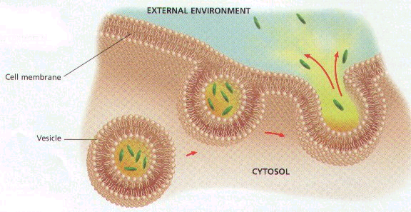Cell Membrane Active Transport:

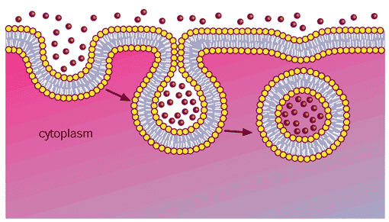

Exocytosis : Transport of material out of cell

Endocytosis of *solids* is called **phagocytosis**

Endocytosis of *Liquids* is called **pinocytosis**

Membranes at work

|  |  |
| --- | --- |
| Function | Description |
| ***Reverse Osmosis*** | is a process used to purify water in which water is filtered through an artificial membrane containing very fine pores. |
| ***Kidney Dialysis***: | blood is pumped through tubing made from a synthetic, semi-permeable membrane (***dialysis tubing***) that is immersed in a salt solution with a concentration similar to blood, but which does not contain wastes. The pores in the tubing allow small dissolved waste molecules to diffuse out of the blood while retaining large proteins and blood cells. |
| ***Transdermal Patch***: | a semi-permeable skin patch which allows medications to diffuse out of the patch and in to the body at a slow, constant rate. Another method to deliver medication is by artificial vesicles called ***liposomes*** |

**Review of Cell Transport Processes**

|  |  |  |  |
| --- | --- | --- | --- |
| **Characteristics** | **Simple Diffusion** | **Endocytosis** | **Active Transport** |
| Active or Passive process? |  |  |  |
| External energy required? |  |  |  |
| Direction of movement in relation to concentration gradient (with or against) |  |  |  |
| Size of matter involved |  |  |  |
| Examples of Matter |  |  |  |
| Where might this process occur? |  |  |  |

**Applications of Cellular Transport**

1. What is **membrane technologies**?
2. Differentiate between **recognition** and **receptor proteins**. How are researchers using their understanding of the protein in their fight against HIV and cancer?
3. Draw and label a diagram of a **liposome**. How are liposomes being used in the treatment of HIV and cancer patients?
4. Explain the importance of membrane binding to the action of **insulin**.
5. What is **dialysis**? Differentiate between **peritoneal dialysis** and **hemodialysis**.
6. What do we use **reverse osmosis (RO)** for and how does it differ from regular osmosis?

**Surface Area to Volume Ratio and Levels of Organization**

* Cells are restricted to a size that assures a surface area to volume ratio that provides _____________________________________________ ________________________________________________________.
* As a cell increases in size, its volume grows __________ than does its surface area (membrane).
* When the cell membrane can no longer provide the cell with material for life processes or rid the cell of wastes – _____________________.

**Answer the questions below and label the diagram using following information:**

**1. Define the following terms: Label the diagram**

a. cell

b. tissue

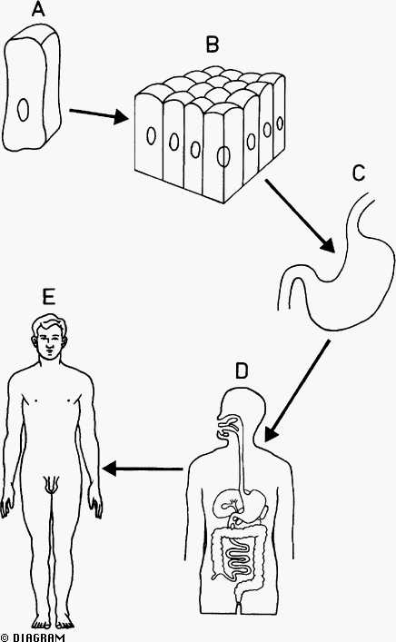

c. organ

d. organ system

e. organism

Surface Area to Volume Ratio Calculations

* Cells are restricted to a size that assures a surface area to volume ratio that provides a sufficient membrane area to meet the transport needs of a cell.
* As a cell increases in size, its volume grows faster than does its surface area (membrane).
* When the cell membrane can no longer provide the cell with material for life processes or rid the cell of wastes – the cell divides.
* Explained mathematically, as surface area is squared, the volume is cubed.

Example:

**1 cm**

**SA = 6 (sides) x 1cm x 1cm = 6 cm2 = 6:1**

**Vol = 1 cm x 1 cm x 1 cm =1 cm3**

**2 cm**

**SA = 6 (sides) x 2cm x 2cm 24 cm2 = 3:1**

**Vol = 2 cm x 2 cm x 2 cm 8 cm3**

What would be the surface area to volume ratio of a cube with all sides 5-cm?

Science 10 Cell - Surface Area to Volume Ratio Assignment

|  |  |  |  |
| --- | --- | --- | --- |
| Hypothetical Box Cell | Volume  (v, cm3) | Surface Area  (SA, cm2) | **SA : V** |
| 1 cm x 1 cm 1 cm | 1 | 6 | 6:1 |
| 2 cm x 2 cm x 2 cm | 8 | 24 | 3:1 |
| 4 cm x 4 cm x 3 cm | 64 | 96 | 3:2 |
| 8 cm x 8 cm x 7 cm | 512 | 384 | 3:4 |