**Science 10**

**Unit C Biology**

**Chapter 4: Multicellularity in Plants**

**Name:**

|  |  |  |  |
| --- | --- | --- | --- |
| **Day** | **Key Concepts** | **Pages** | **Homework** |
| 1 | * Plant Structures * Gas Exchange | * #1-3 * #4-5 | * Page 3 |
| 2 | * Water Exchange * Tropisms | * #6 * #7 | * Graphic Organizer |
| 3 | * Review * Graphic Organizer |  | * Graphic Organizer |
| 4 | * **Chapter 4 Quiz** | * 1-7 |  |

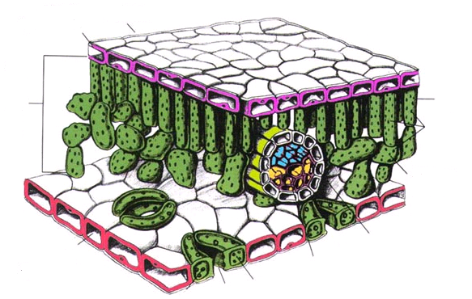

**Multicellularity - Focus on Plants**

**9.1: Plant Structure – Specialized and Organized**

**Cell specialization**

* Leaves contain many types of specialized cells that function for one main reason, **PHOTOSYNTHESIS**.

**Leaf Structure**

**Epidermal Cells**

* Upper and lower epidermal cells are _Upper and lower epidermal cells are tightly interlocked to prevent physical damage or penetration by pathogens __________________________________ ________________________________________________________________________
* 1 layer thick!
* *Waxy cuticle* acts as water barrier to conserve water ________________________________________________________

**Stomata and Guard Cells**

* *Guard cells* on lower epidermis control opening and closing of stomata ____________________________________________________________________________
* allows gas exchange between external and interior photosynthetic cells also conserve water ____________________________________________________________________________

**Vascular Tissue**

* Forms a series of tubes that transport fluid ____________________________________________________________________________
* Look like leaf veins
* 2 kinds
  + ***XYLEM*** *– carries water and mineral from roots to leaves* ________________________________________

.

* + ***PHLOEM*** *–carries sugars produced by leaves to other parts of the plant* ____________________________________

________________

* + Arranged together in a vascular bundle *_________________________*

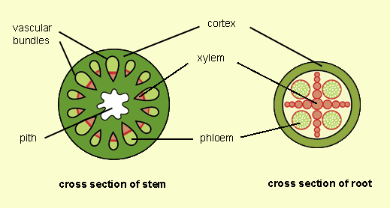**Palisade Tissue – Photosynthesis**

* Long narrow columns of specialized cells packed closely together ________________________________________________________________________

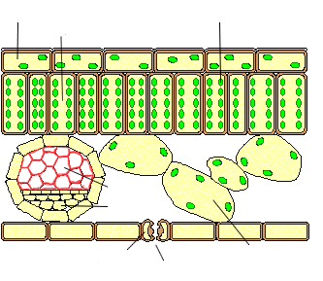

* Efficient for Photosynthesis because
  + Close to upper layer for max sunlight exposure ___________________________________________________
  + Chalk full of chloroplasts (photosynthetic organelles) ___________________________________________________
* Most photosynthesis occurs here

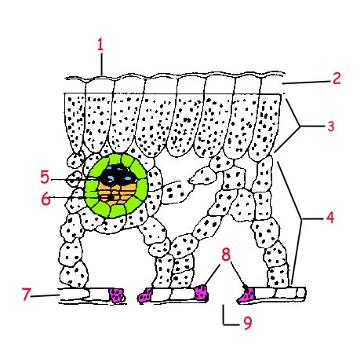**Spongy Tissue**

* few chloroplasts
* ● Round with spaces between them
* ● Gas collect here before being expelled

**Multicellularity:**

* + With more complexity, however, more organization is needed. There are successive levels of organization in multicellular organism. Here is one example.
  + ***Cells***: the most basic unit of organization in organisms.
  + Ex.
  + ***Tissues***: a cluster of similar cells that share the same structure and function.
  + Ex.
  + ***Organ***: a combination of various types of tissue that work together to perform a specific function.
  + Ex.
  + ***System***: a combination of organs and tissues that perform a shared complex function.
  + Ex.
* Assignment: **Plant Structure Summary Chart**

|  |  |  |
| --- | --- | --- |
|  | **Structure**  **(What does it look like?)**  **Draw or Describe** | **Function**  **(What does it do in the plant?)** |
| Epidermal Cells |  |  |
| Palisade Tissue Cells |  |  |
| Spongy Tissue Cells |  |  |
| Stomata |  |  |

|  |  |  |
| --- | --- | --- |
| Guard Cells |  |  |
| Xylem |  |  |
| Phloem |  |  |
| Vascular Bundles |  |  |

**9.2: Gas Exchange in Plants**

Objectives**: After studying this Topic you should be able to:**

* Compare how selected organisms exchange gases, and discussing the difference in terms of the structure and function of the organisms: e.g., unicellular and multicellular.
* Compare how selected organisms acquire nutrients and remove wastes, and discussing the differences in terms of the structure and function of the organisms; e.g., unicellular and multicellular.

Comparison of Gas Exchange

* The air we breathe is a mixture of_______________, _____________, _____________, ____________, and _____________.
* Both plants and animals consume oxygen and produce carbon dioxide and water during _________________________.
* Plants, however, are capable of _________________ in which they consume the ______________ and ____________ and produce ____________ and ___________.

***Cellular Respiration:***

***Photosynthesis:***

Differentiate between exothermic and endothermic reactions.

Differentiate between catabolic and anabolic reactions.

There are some ecosystems that have no light, so producers like bacteria convert (with the help of thermal energy) inorganic molecules such as sulphur and methane into food and energy. This anabolic/catabolic, exothermic/endothermic reaction is called **_______________**.

* In fact, when plants undergo photosynthesis, they consume much more carbon dioxide than they release during cellular respiration.

Transpiration

* A tree can lose 200L of water per day!
* Must regulate water loss by ____________ guard cells
* If guard cells are closed **no** gas can enter and photosynthesis is reduced.

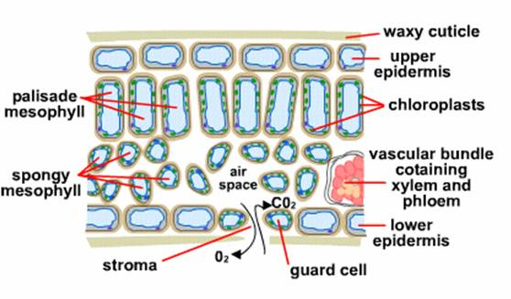

* Water moves into the guard cells by _____________, and as it does so, the pressure inside the cells increases and causes the cells to swell.
* 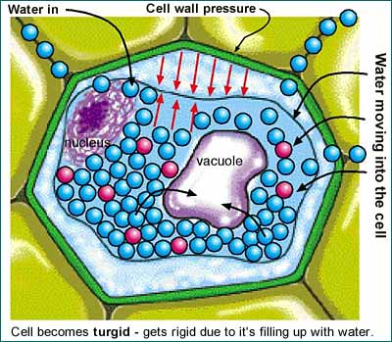This high pressure, called ***_______________***, causes the cells to remain rigid.
* As transpiration occurs, water exits the cells and ___________.
* In most plants, the stomata are open during the day and close at night.
  + Factors that affect the rate of transpiration include:
  + ___________________ ____________________
  + ___________________ ____________________

**9.3: Water Exchange in Plants**

* Nutrition: _______________________________________________
* Transportation systems: ____________________________________ ________________________________________________________

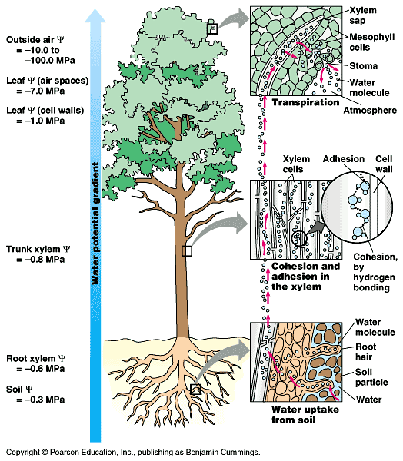

**9.4: Plant Growth**

* ***Stimuli***:
* ***Tropism***:

A tropism is a growth movement whose __________________ is determined by the direction from which the ____________________________________.

* **Positive** =
* **Negative** =

Plants respond to:

* Light =
  + Stems are ____________________ phototropic.
  + Roots are ____________________ phototropic.
* Gravity =
  + Stems are ____________________ gravitropic while
  + Roots are ____________________ gravitropic.

Phototropism

Auxins: Plant Growth Chemicals

Gravitropism